 | NGO Management System  Technical Design Document  1.0
 | Prepared By / Last Updated By | Prepared By / Last Updated By | Prepared By / Last Updated By | Prepared By / Last Updated By | Prepared By / Last Updated By | Reviewed By | Approved By
Name | Aayushi Sen | Richa Nema | Geet Jigyasi | Ayushi Agarwal | Poornima Singh | Venkatesh Badiger
Role | Team Member | Team Member | Team Member | Team Member | Team Member | Trainer
Date | 28/03/19 | 28/03/19 | 28/03/19 | 28/03/19 | 28/03/19 | 28/03/19

Table of Contents

1.0 Introduction 3
1.1 Purpose of this document 3
1.2 Scope 3
1.3 Intended Audience 3
1.4 Definition & Acronyms 3
2.0 Conventions and Standards Followed 4
3.0 Assumptions, Dependencies and Risks 4
3.1 Assumptions: 4
3.2 Dependencies: 4
4.0 Schematic Diagram 4
5.0 Use Case Realization 5
5.1.1 User Registration 5
a. Functional Requirement 6
b. UI Validations 6
c. UI Controls 7
d. UI Methods Definition 8
e. UI Design 9
6.0 Database Design 10
6.1 Data Model 10
6.2 Tables Structure 10
7.0 Change Log 13

Introduction

Purpose of this document
The purpose of the detail design document is to define the detailed design for all the components of NGO Management system that are specified in the Business Requirement/Use case document. All the low level components, interfaces and integrations are detailed out in this document.

Scope
This sub-section shall state the scope of this detailed design document
- Create and maintain user information.
- Create and maintain NGO’s information.
- Create and maintain event’s information.

Intended Audience
The intended audience for this document are
- Developers, testers, other associates in the project
- Technical lead, Scrum Master
- Product Owner

Conventions and Standards Followed
The modules under scope needs to adhere to the coding standards and guidelines
..\Java_standards_V1.0.pdf

Assumptions, Dependencies and Risks

Assumptions:
- Once the event is created the Homepage will manually load the event’s list into the system.
- There will be no concurrent users for the application. The profile will be maintained by the Admin.
- Any changes to the design mentioned in the BRD would be taken as a Change Request

Dependencies:
- Availability of database design characteristics & access shall be defined by the
- Resource availability throughout each of the sprint

Schematic Diagram
A schematic, or schematic diagram, is a representation of the elements of a system using abstract, graphic symbols rather than realistic pictures. It gives an overview of overall system
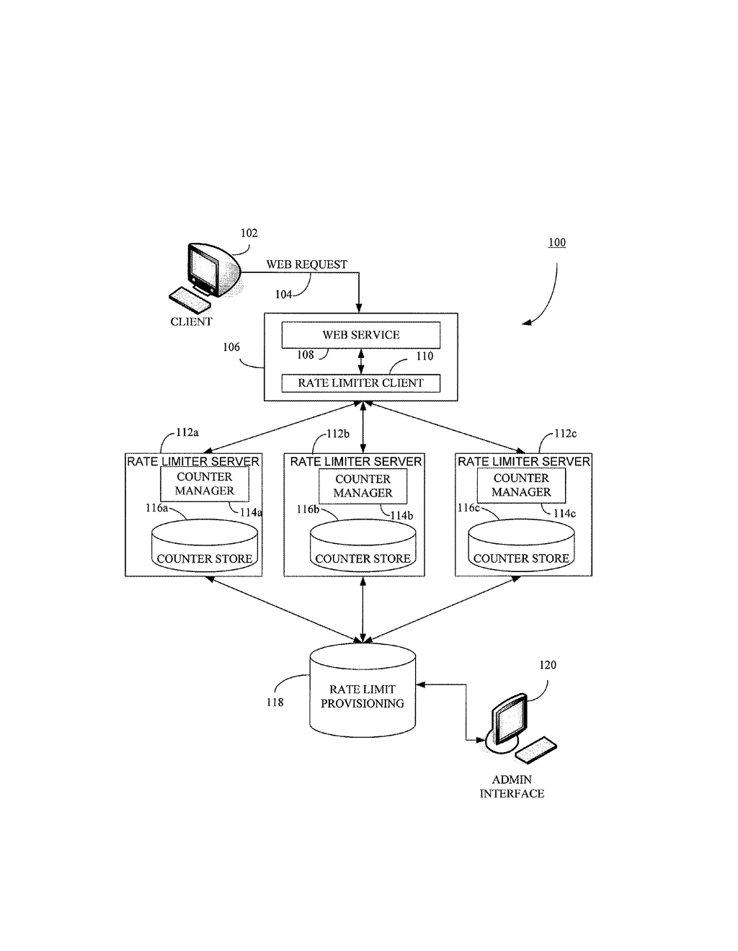
The above pic is only an example and not representational of the NGO management project

Use Case Realization

User Registration

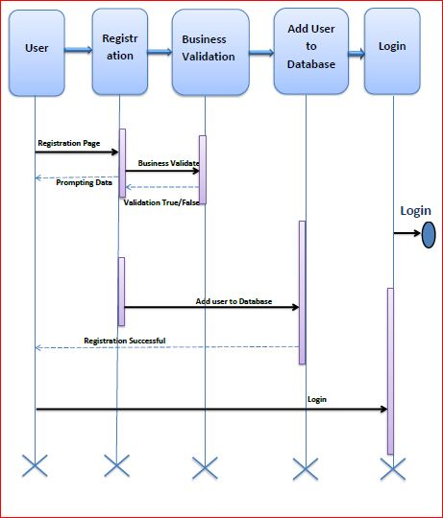

Functional Requirement
. Login Page checks the authentication of the User/NGO/Admin and based on his role, directs the user/NGO/Admin to the respective page. User/NGO will be provided with Add Event, Details, Post about events and the same user/NGO along with the Admin will be allowed to modify any changes in the event.

UI Validations
- User Id and Password fields are mandatory.
- Invalid User Id and / or password should not allow the user to get into the system

UI Controls
# | UI Component | Type | Name | Details
1 | User Id | Label | label_For_User_Id
2 | User | Text field | Textfield_user | To enter username
3 | password | Label | Label_for_password
4 | password | Text field | Textfield_password | To enter password

UI Methods Definition
Method Name | Parameter | Details
SignButton_Click | object sender, EventArgs e | Allows the user/admin/NGO to login into the portal.
RegisterButton_Click | object sender, EventArgs e | Allows the user/NGO to insert the User/NGO personal details
ResetButton_Click | object sender, EventArgs e | Resets all fields given by user/NGO.

UI Design
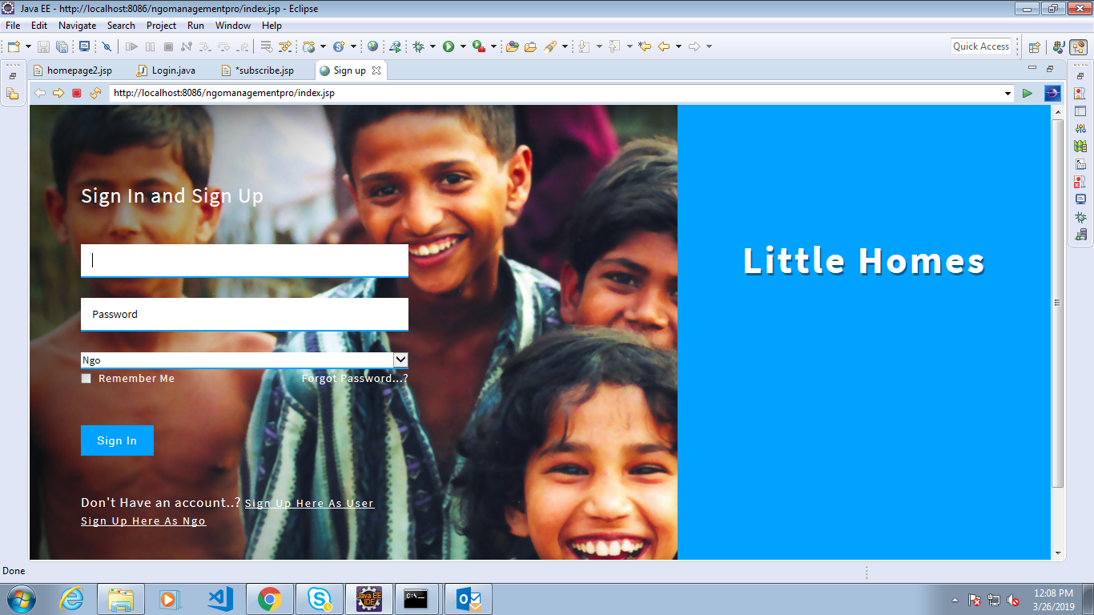

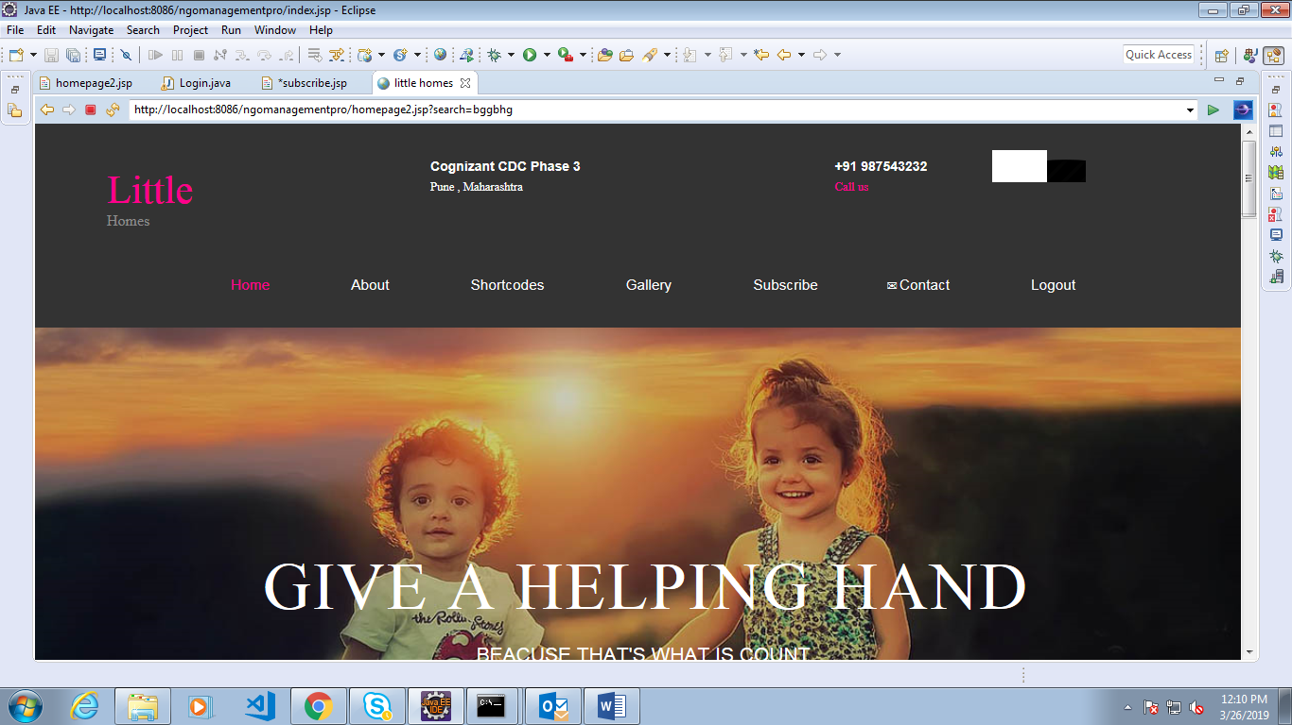

Database Design

Data Model

The following is a schematic view of the database design

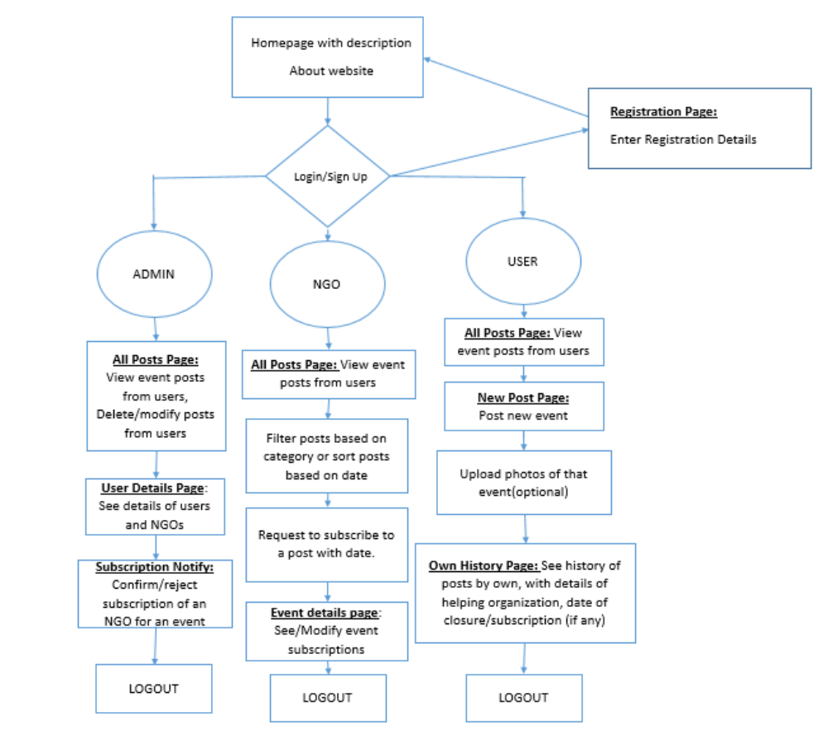

Tables Structure
User Registration:
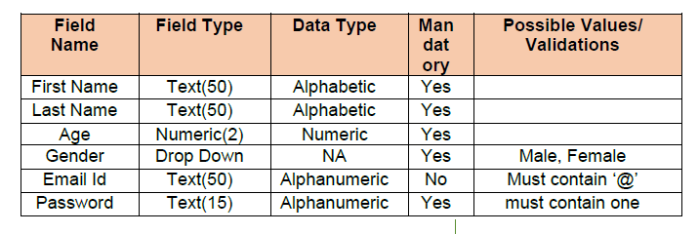
User login:
Column Name | Data Type | Length | Nulls
User Id | nvarchar | 50 | N
Password | nvarchar | 50 | N

NGO Registration:
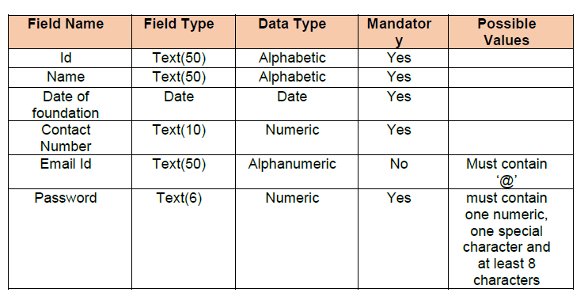

Event Information:
